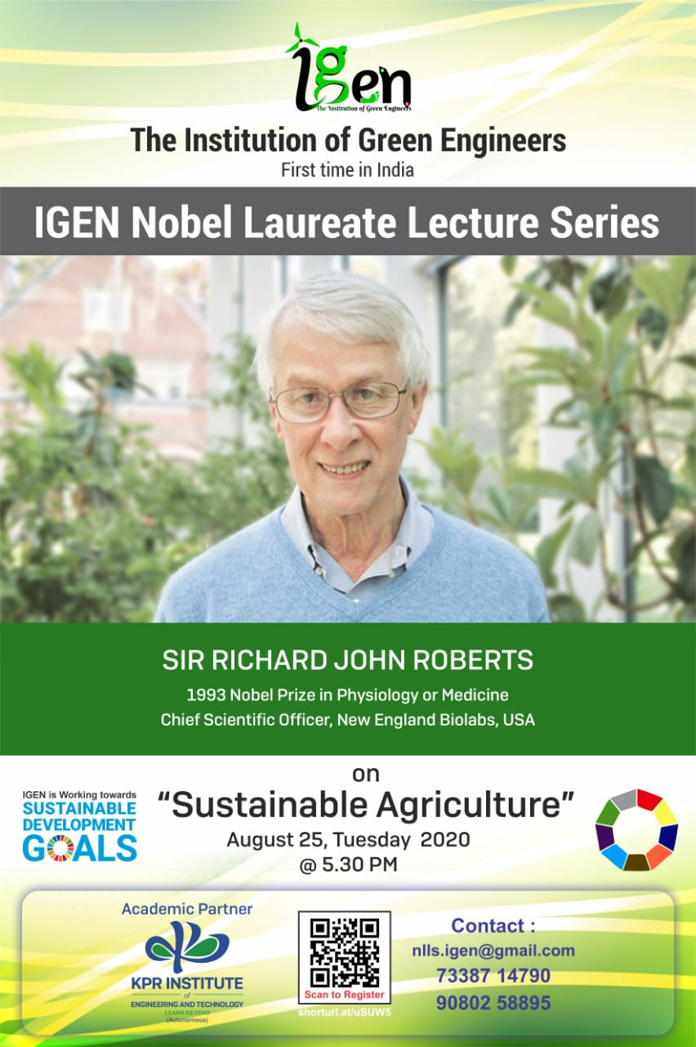

**An Awe-Inspiring International Multifold Competition about Nobel Laureate (your thoughts Your Creativity)**

***POSTER/ PPT PRESENTATION***

*-GET CREATIVE*

**RULES:**

* *Exhibit your ideas in the form of* ***posters*** *or* ***Power point*** *presentations on***,**

***Sir Richard John Roberts – Nobel Laureate in Physiology or Medicine***

(Or)

***How would you see Sustainable Agriculture in 2050?***

* *Telecast your ideas with audio in the form of Posters / PPT*
* *2-3 Minutes of presentation on the given topic*
* *Eligiblity Criteria* **-*Faculties of any stream/ Research Scholars/ Industrialists/ Any Professionals***

**AWARDS:**

* A medal and a certificate holding the ***Signature*** of ***Nobel Laureate Sir Richard John Roberts*** will be given to ***best 3 entries***.
* ***Winning entries*** will be ***showcased*** during the ***live streaming*** of the event and also published on “IGEN Nobel Laureate Lecture Series” website.

For more information on the above, contact,

Dr.A.K.PRIYA (88708 02844)

MR. A. KADHIRAVAN (76394 77452)